ASSIGNMENT

***WAQAS ASHIQ.***

***BCS-F11-201.***

***LABSHEET 5.***

***SUBMITTED TO:***

***DR .ALI HASSAN***

**Q#1:**

/*ARRAY OF STRUCTURE*/

CODE:

#include<stdio.h>

struct student

{

char name[50];

int roll;

float CGPA;

};

int main()

{

struct student s1[5];

for(int i=0;i<5;i++)

{

printf("\nenter the name of student %d:",i+1);

scanf("%s",&s1[i].name);

printf("\nenter the roll number of student %d:",i+1);

scanf("%d",&s1[i].roll);

printf("\nenter the CGPA of student %d:",i+1);

scanf("%f",&s1[i].CGPA);

}

printf("\n\nNAME\t\tROLLNUMBER\t\tCGPA");

for(int a=0;a<5;a++)

{

printf("\n\n%s%16.d%23.2f",s1[a].name,s1[a].roll,s1[a].CGPA);

}

printf("\n\n\n\n\n");

}

OUTPUT:

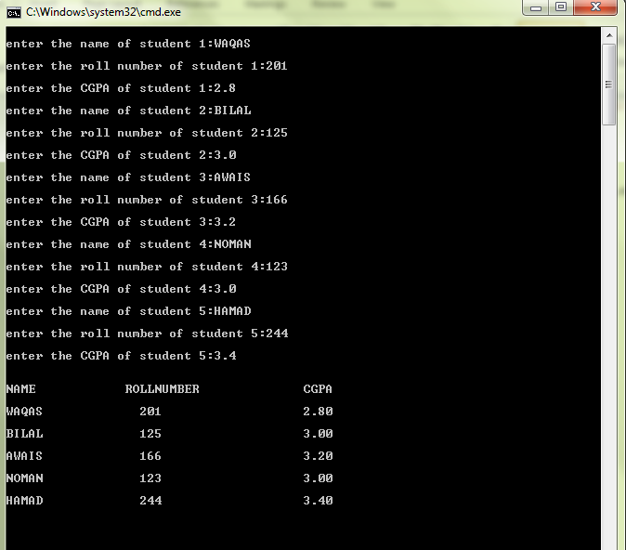

**Q#2:**

/*PASSING ARRAY STURUCTURE TO FUNCTIONS*/

**CODE:**

#include<stdio.h>

struct student

{

char name[50];

int roll;

float CGPA;

};

void print_student_record(struct student s1[]);

void main()

{

struct student s1[5];

for(int i=0;i<5;i++)

{

printf("\nenter the name of student %d:",i+1);

scanf("%s",&s1[i].name);

printf("\nenter the roll number of student %d:",i+1);

scanf("%d",&s1[i].roll);

printf("\nenter the CGPA of student %d:",i+1);

scanf("%f",&s1[i].CGPA);

}

print_student_record (s1);

}

void print_student_record(struct student s1[])

{

printf("\n\nNAME\t\tROLLNUMBER\t\tCGPA");

for(int a=0;a<5;a++)

{

printf("\n\n%s%16.d%23.2f",s1[a].name,s1[a].roll,s1[a].CGPA);

}

printf("\n\n\n\n\n");

}

**OUTPUT:**

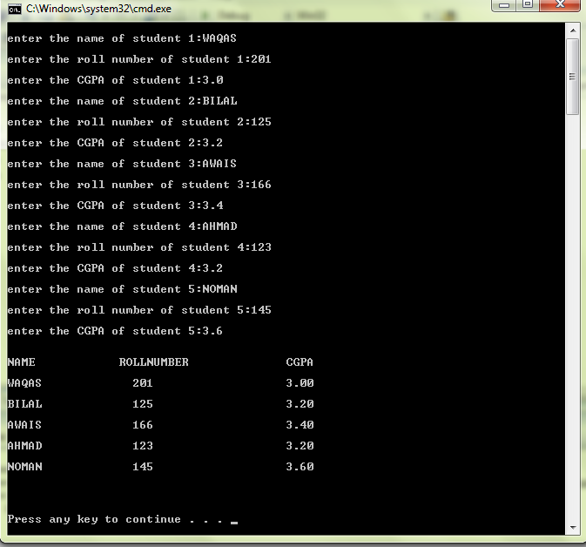

Q#3

CODE:

#include<stdio.h>

void write_to_file(struct student s1[]);

void read_from_file(struct student s1[]);

void apend_file(struct student s1[]);

struct student

{

char name[50];

int roll;

float CGPA;

};

void main()

{

struct student s1[5];

write_to_file (s1);

read_from_file (s1);

apend_file (s1);

}

void write_to_file( struct student s1[] )

{

FILE *cfPtr;

if ( ( cfPtr=fopen( "Student.txt","w" ) ) == NULL )

{

printf( "Failed to open the requested File....\n" );

}

else

{

for( int i=0;i<5;i++ )

{

printf( "Enter the Name of the Student: " );

scanf( "%s",s1[i].name );

printf( "\nEnter the Roll Number of the Student: " );

scanf( "%d",&s1[i].roll );

printf( "\nEnter the CGPA of the Student: " );

scanf( "%f",&s1[i].CGPA );

printf ( "\n\n" );

}

printf( "\n\nName\t\tRollNumber\t\tCGPA" );

for(int a=0; a<5; a++ )

{

fprintf( cfPtr,"\n\n%s%16.d%23.2f",s1[a].name,s1[a].roll,s1[a].CGPA);

printf( "\n\n%s%16.d%23.2f",s1[a].name,s1[a].roll,s1[a].CGPA );

}

printf( "\n\n" );

}

fclose( cfPtr );

}

void read_from_file(struct student s1[])

{

printf("=========================================================================");

printf("\n\t\tTHE DATA TO BE READED");

FILE *cfPtr;

if ( (cfPtr=fopen("Students.txt","r") ) == NULL )

{

printf("Failed to open the requested file...\n");

}

else

{

cfPtr = fopen("Students.txt","r");

for(int i=0;i<5;i++)

{

fscanf( cfPtr,"\n\n%s%16.d%23.2f",s1[i].name,s1[i].roll,s1[i].CGPA);

printf( "\n\n%s%16.d%23.2f",s1[i].name,s1[i].roll,s1[i].CGPA);

}

fclose ( cfPtr );

}

printf ( "\n\n" );

}

void apend_file(struct student s1[])

{

int i=0;

printf("==========================================================================");

printf("\n\t\tTHE DATA TO BE APPENED");

FILE *cfPtr;

if ( ( cfPtr=fopen( "Students.txt","a" ) ) == NULL )

{

printf( "Failed to open the requested File....\n" );

}

else

{

printf( "Enter the Name of the Student: " );

scanf( "%s",s1[i].name );

printf( "\nEnter the Roll Number of the Student: " );

scanf( "%d",&s1[i].roll );

printf( "\nEnter the CGPA of the Student: " );

scanf( "%f",&s1[i].CGPA );

printf ( "\n\n" );

printf( "\n\nName\t\tRollNumber\t\tCGPA" );

fprintf( cfPtr,"\n\n%s%16.d%23.2f",s1[i].name,s1[i].roll,s1[i].CGPA);

printf( "\n\n%s%16.d%23.2f",s1[i].name,s1[i].roll,s1[i].CGPA );

printf( "\n\n" );

}

fclose( cfPtr );

}

OUT PUT:

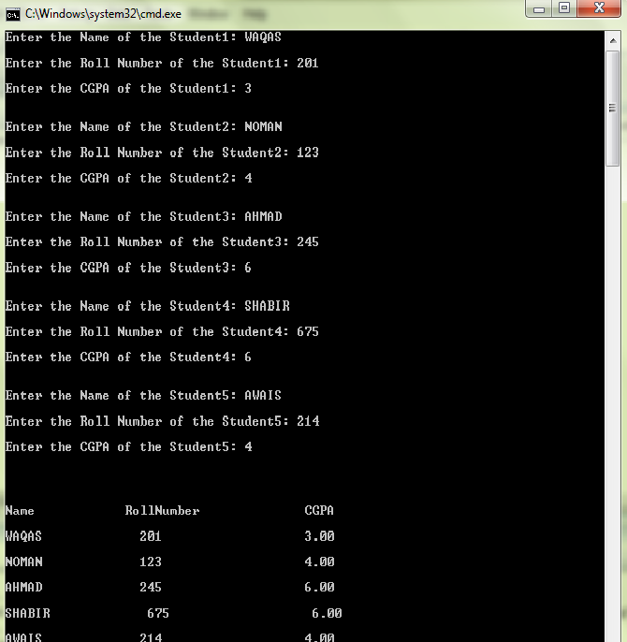

/*THE OUT PUT SCREEN IS NOT COMPLETE IT IS READING AND APPENDING DATA FORM THE FILE BUT NOT SHOWN IN THE OUT PUT DUE TO SHORT SCREEN*/

Q#4:

CODE:

#include<stdio.h>

void write_to_file(struct EmpRecord s1);

void read_from_file(struct EmpRecord s1);

struct EmpRecord

{

int Emp_id;

char Name[50];

float HourlyRate;

float HoursWorked;

};

void write_to_file(struct EmpRecord s1)

{

printf("Enter the id of employee ranging from 1-10: \n");

scanf("%d",&s1.Emp_id);

FILE *cfPtr;

if ( (cfPtr=fopen("Employee.txt","rb+") ) == NULL )

{

printf( "Failed to open the requested file.....\n" );

}

else

{

while( s1.Emp_id!=0 )

{

fopen( "Employee.txt","wb" );

printf("Enter name of the employee: ");

scanf("%s",s1.Name);

printf("Enter HourlyRate of employee: ");

scanf("%f",&s1.HourlyRate);

printf("Enter hourlywork rate of employee: ");

scanf("%f",&s1.HoursWorked);

fseek(cfPtr,(s1.Emp_id-1)*sizeof(struct EmpRecord),SEEK_SET);

fwrite(&s1,sizeof(struct EmpRecord),1,cfPtr);

printf("Enter the employ id from 1-10:");

scanf("%d",&s1.Emp_id);

}

}

fclose( cfPtr );

}

void main()

{

struct EmpRecord s1={0,"",0.0,0.0};

write_to_file(s1);

read_from_file(s1);

}

void read_from_file(struct EmpRecord s1)

{

FILE *cfPtr;

if( (cfPtr=fopen("Employee.txt","rb") ) == NULL )

{

printf( "Failed to open the requested file....\n" );

}

else

{

while( s1.Emp_id!=0 )

{

fread(&s1,sizeof(struct EmpRecord),1,cfPtr);

printf ( "%-6s%-16.2f%-11.2f\n",s1.Name,&s1.HourlyRate,&s1.HoursWorked );

}

}

fclose( cfPtr );

}